EPOLICE ONLINE SYSTEM



GROUP 11

VM Hlabangane 50158929

A Pilingane 45372039

TSS Mthethwa 45088756

P Lejapela 45083150

K Hadebe 45600600

LM Sithole 40899608

JD Mashinini 47219815

Contents

Physical Data Model 3

Physical Process Model 4

Database Schema 5

Creating the Database 6

Administrator Table: 6

Case Table: 6

Evidence Table: 7

Suspect Table: 7

Victim Table: 7

Documents Table: 8

Maintaining all the tables 8

Maintaining Admin 8

Maintaining Cases 10

Maintaining Victims 11

Maintaining Suspects 12

Maintaining Documents 13

Maintaining Evidence 14

Querying the database 15

For Login 15

For Output 15

Maintaining a child entity 16

# Physical Data Model

# Physical Process Model

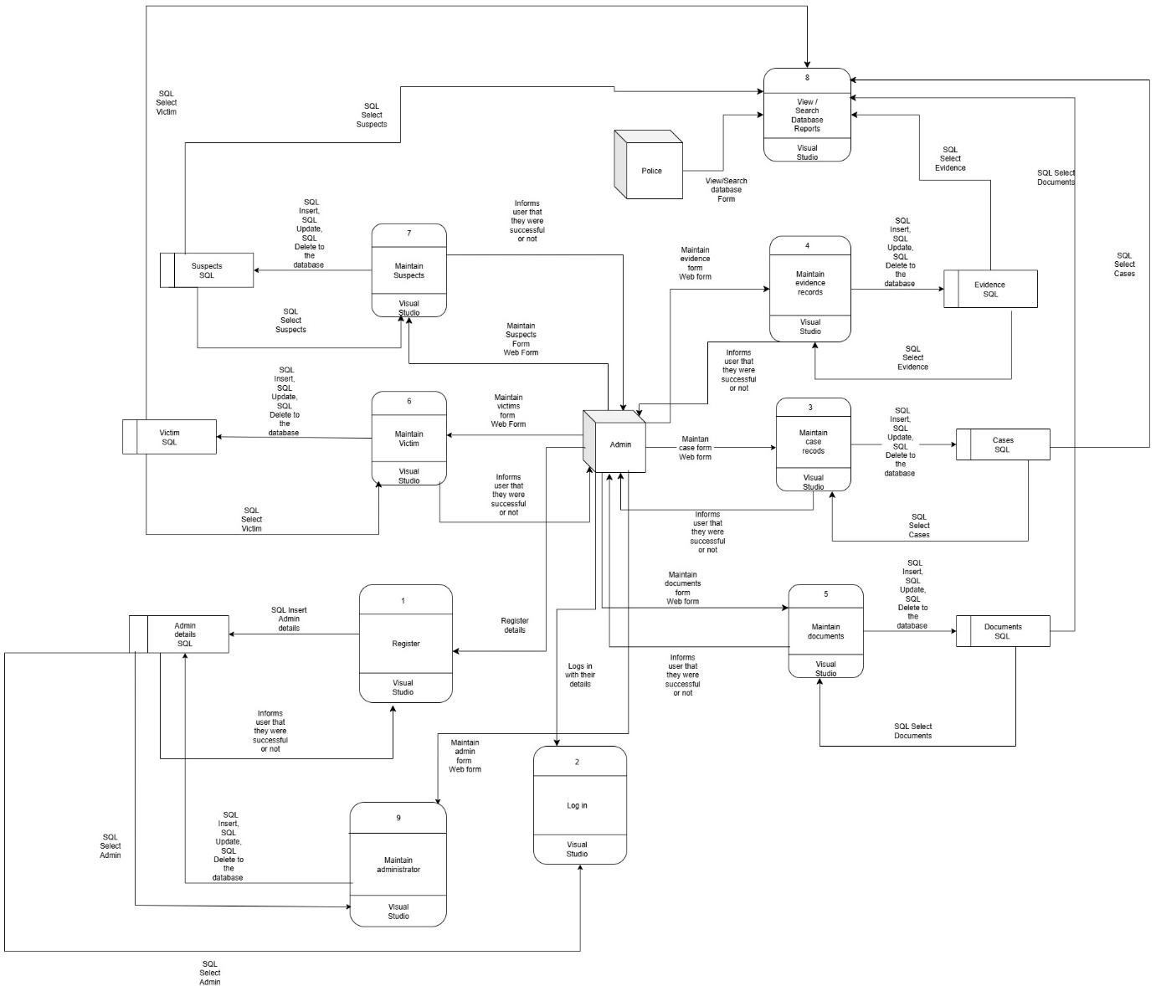

# Database Schema

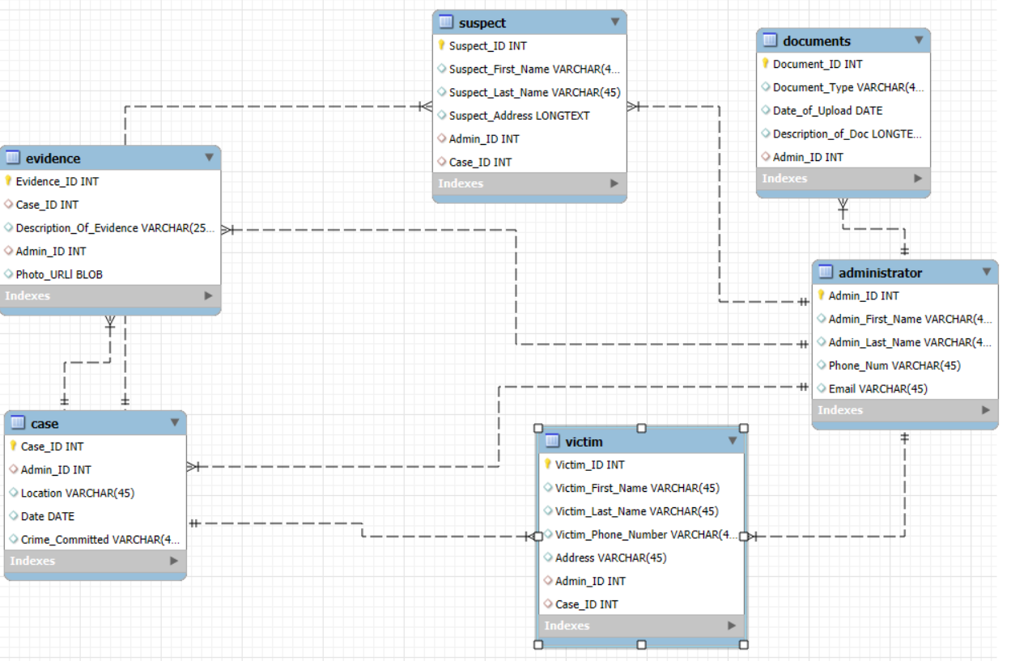

# Creating the Database

## Administrator Table:

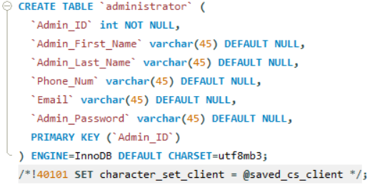

## Case Table:

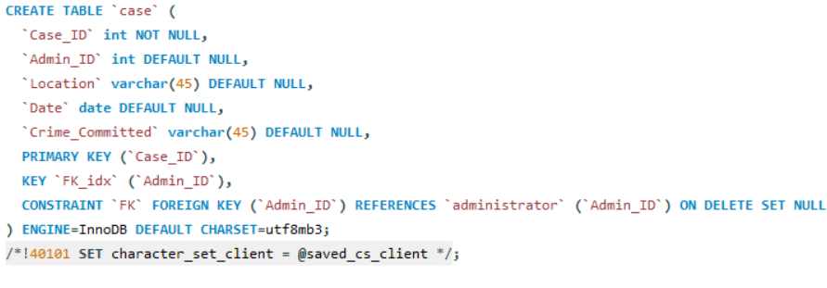

## Evidence Table:

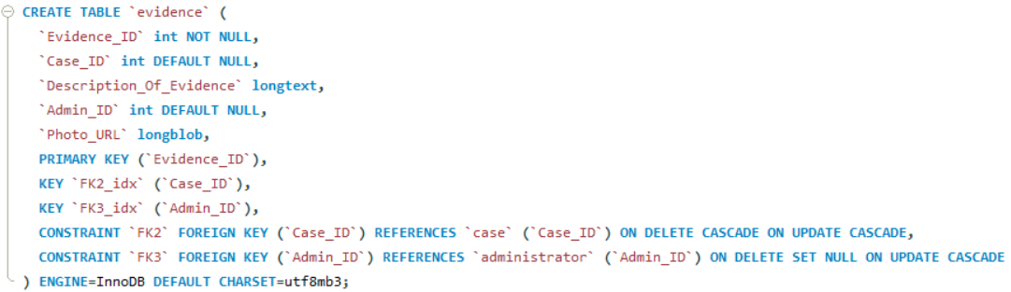

## Suspect Table:

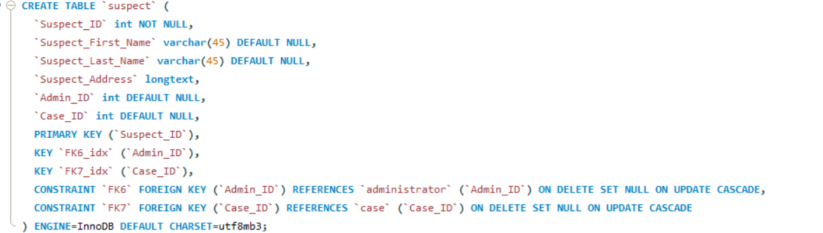

## Victim Table:

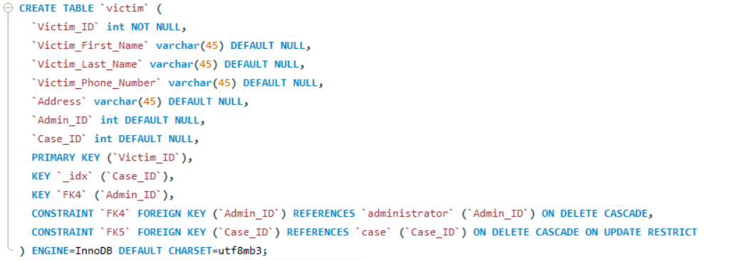

## Documents Table:

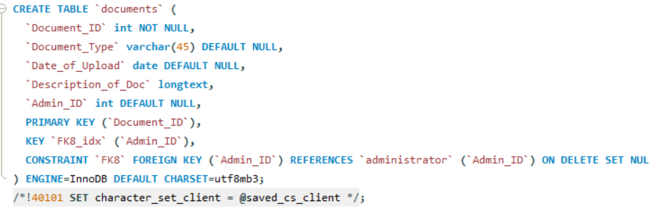

# Maintaining all the tables

Maintaining Admin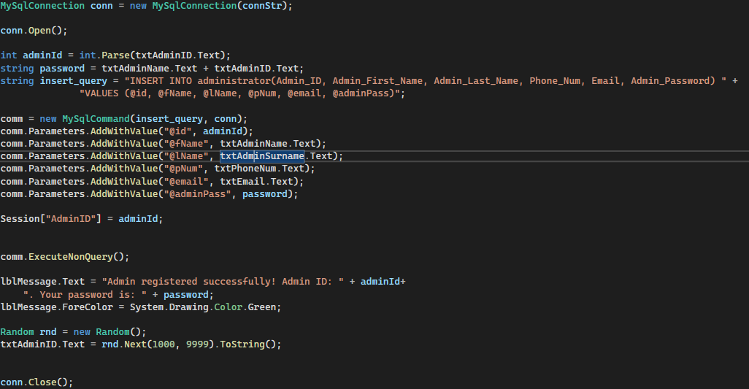  
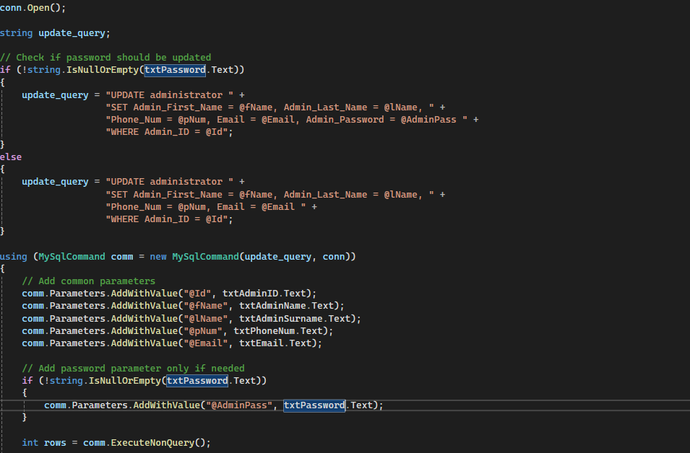  
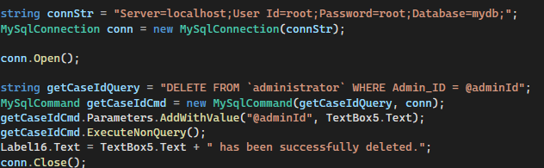

## Maintaining Cases

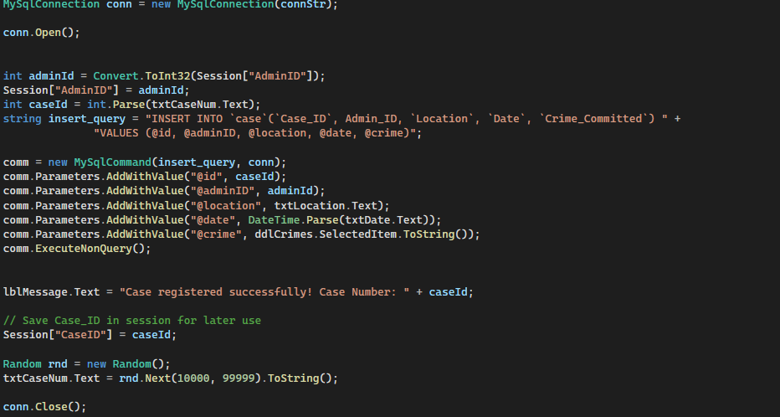  
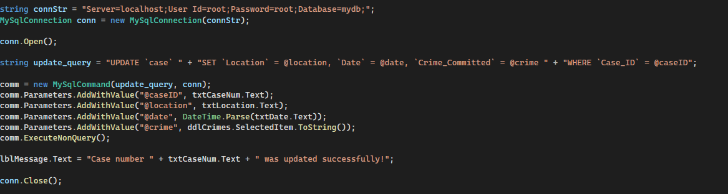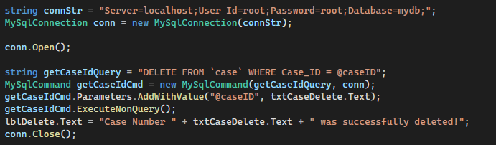

## Maintaining Victims

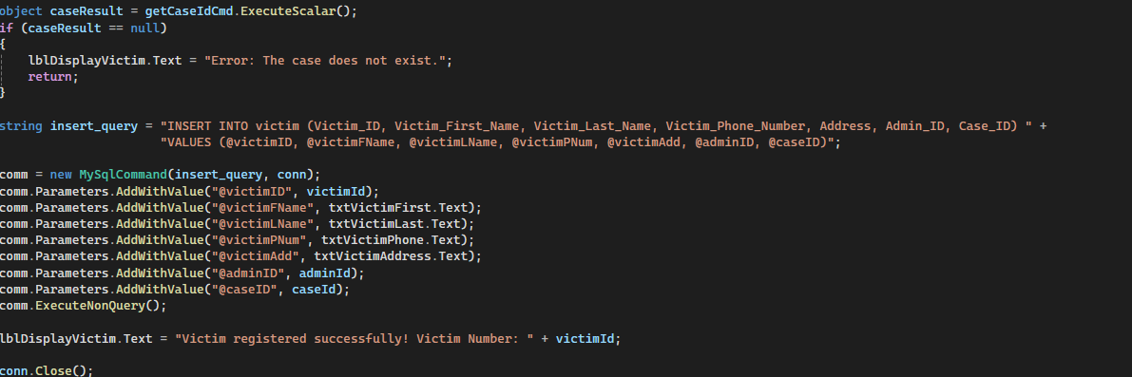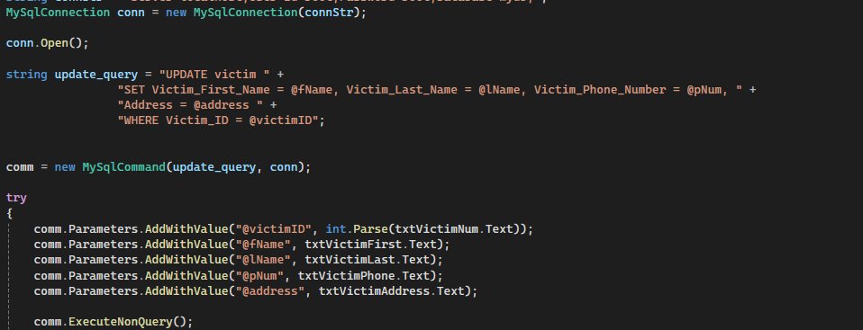  
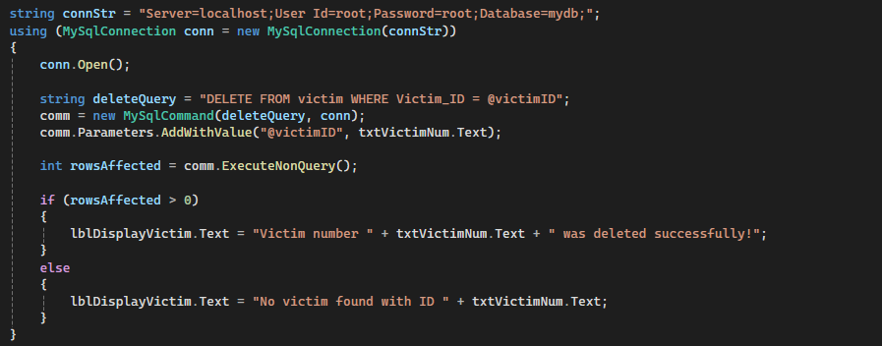

## Maintaining Suspects

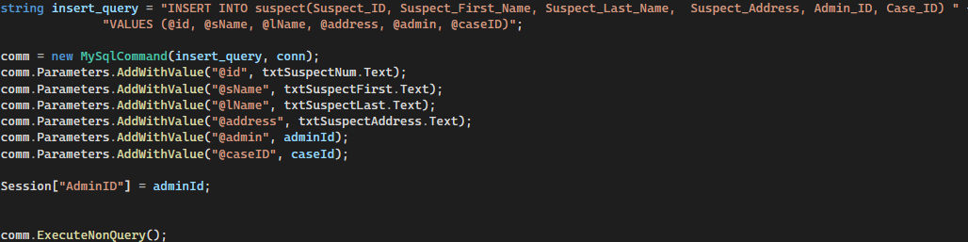  
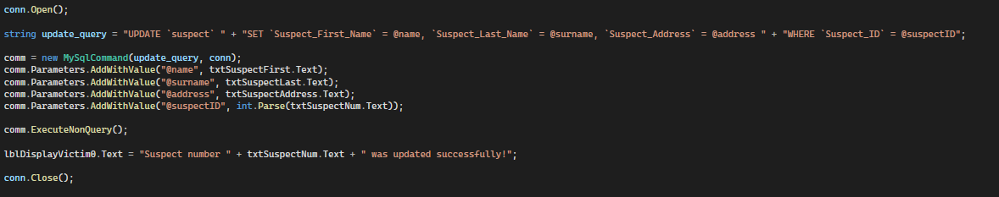  


# Querying the database

## For Login

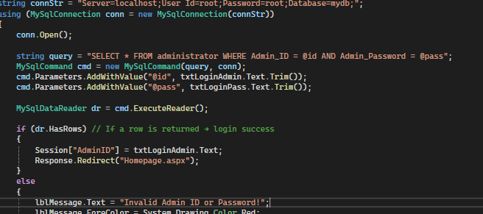

## For Output

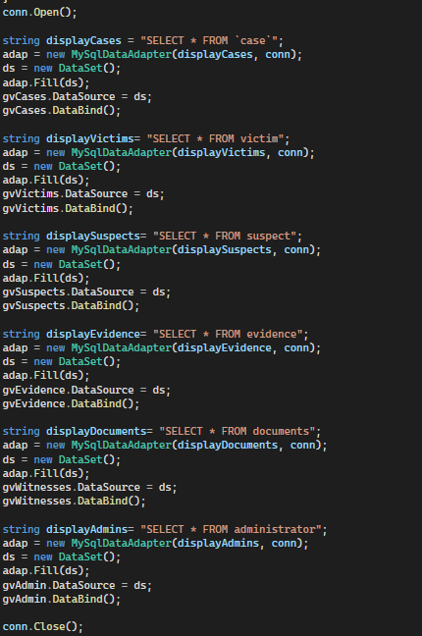

# Maintaining a child entity

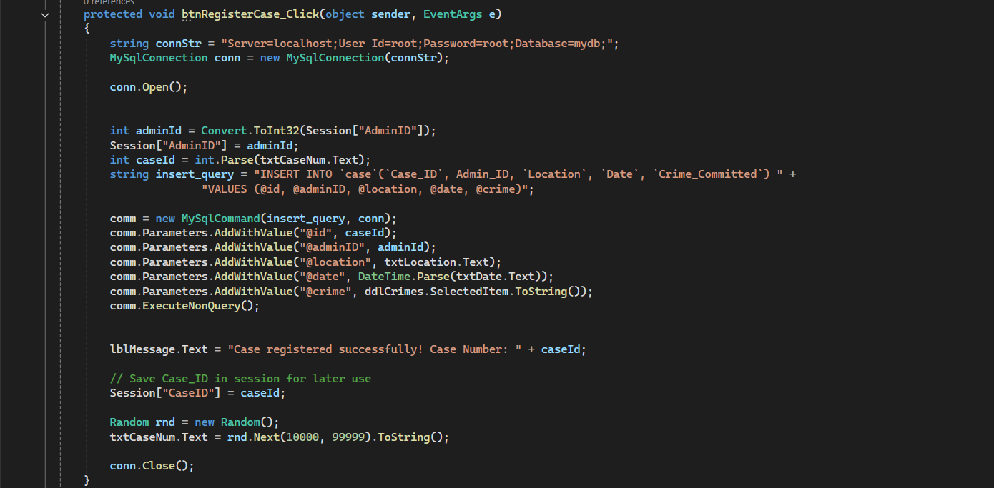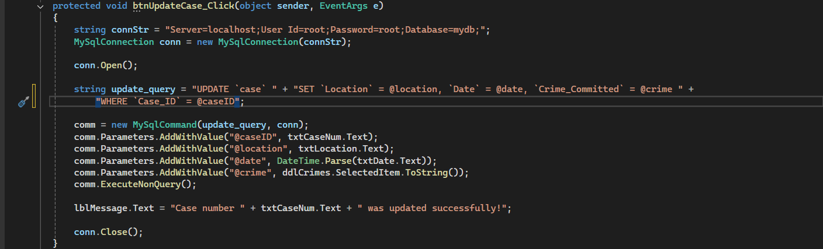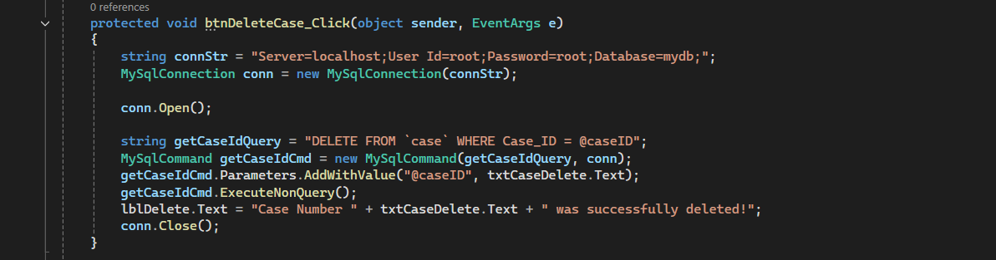

EPOLICE ONLINE SYSTEM



USER MANUAL

TABLE OF CONTENTS

Technical requirements……………………………………….18

Getting the system installed…………………………………18

Launching the application……………………………………18

Administrator……………………………………………………..19

Registration…………………………………………………….19

Logging in……………………………………………………….19

Register case…………………………………………………..20

Register/Update victim……………………………………..20

Register/Update suspect…………………………………..21

Register/Update Evidence…………………………………21

Register/Update case document details……………..22

Delete operations……………………………………………23

View database………………………………………………..24/25

Search by crime………………………………………………25

Search by case ID……………………………………………26

Search by Admin ID…………………………………………27

Detective………………………………………………………..

Logging in………………………………………………………28

View database………………………………………………..24/25

Search by crime………………………………………………25

Search by case ID……………………………………………26

**TECHNICAL REQUIREMENTS**

Minimum System Requirements

a 1 GHz or faster processor with 2+ cores on a 64-bit CPU  
8 GB of RAM, 64 GB of HDD storage   
720p or higher HD display.   
Additionally, internet connectivity and a Microsoft account are required for setup and certain features.

Steps

Download Visual Studio

Download EPOLICE zip file

Extract the file to the desktop

Install MYSQL in the machine with all the capabilities

Double the folder then double click the solution file (.sln)

**ADMINISTRATOR**

**Registration**

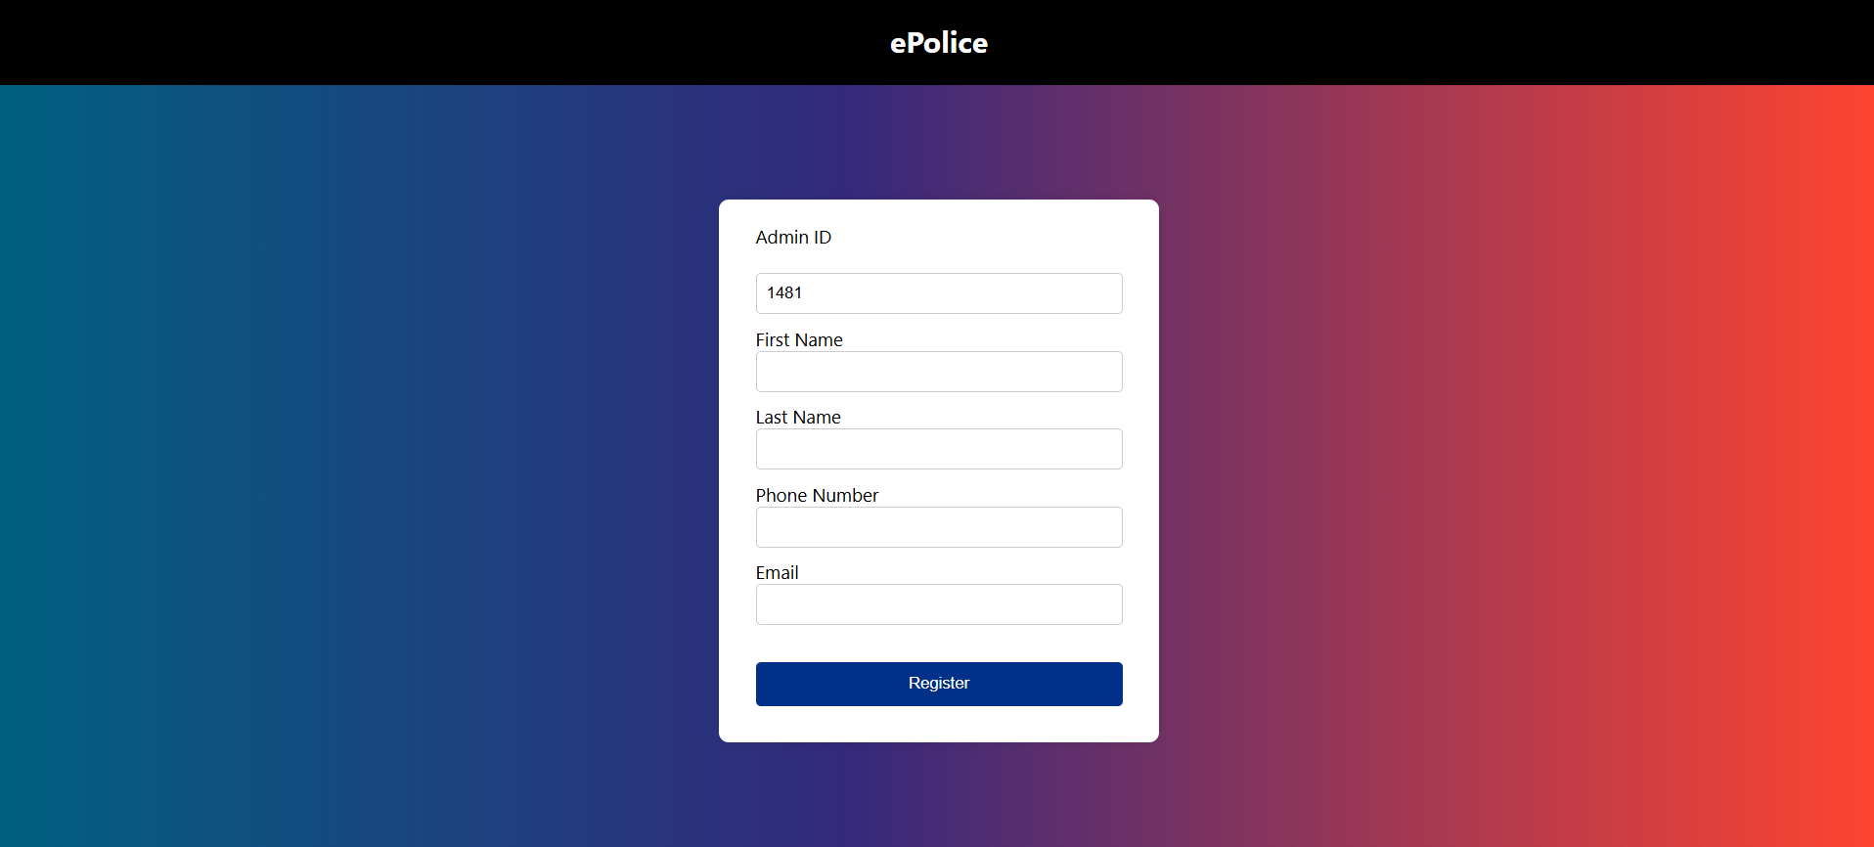

Administrator is required to enter their admin ID, first name, last name, phone number and email to register.

Click on the register button to register successfully.

**Logging in**

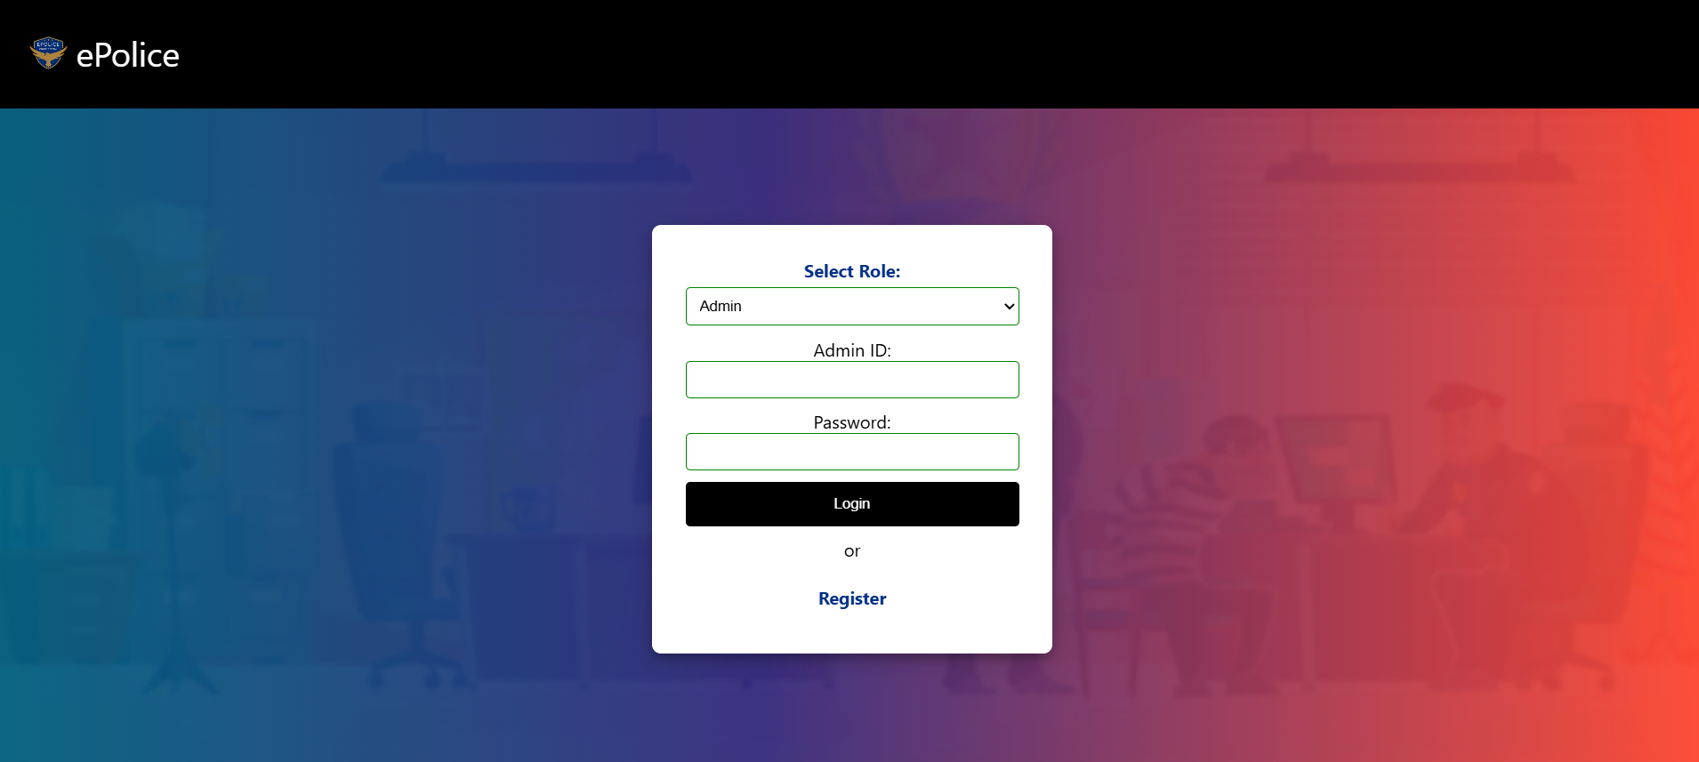

Administrator then logs in by selecting their role, entering their admin ID, and entering their correct password.

Click login to login successfully.

**Register case**

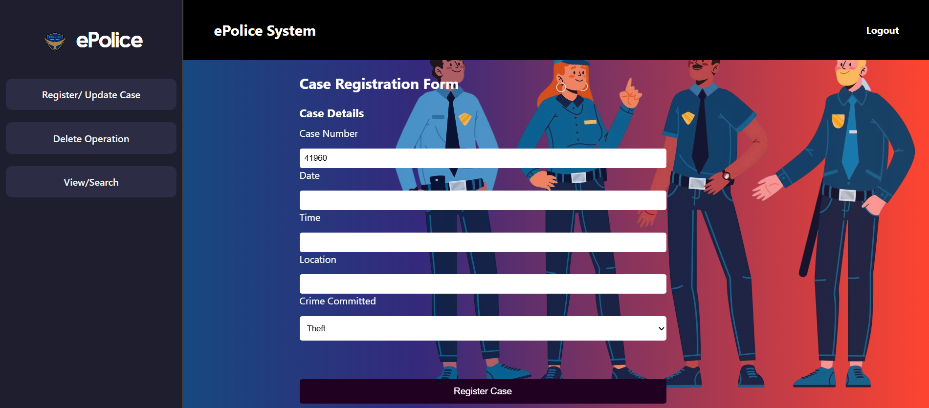

Enter case details to register case

Click on register case button to successfully register the case.

**Register/Update victim**

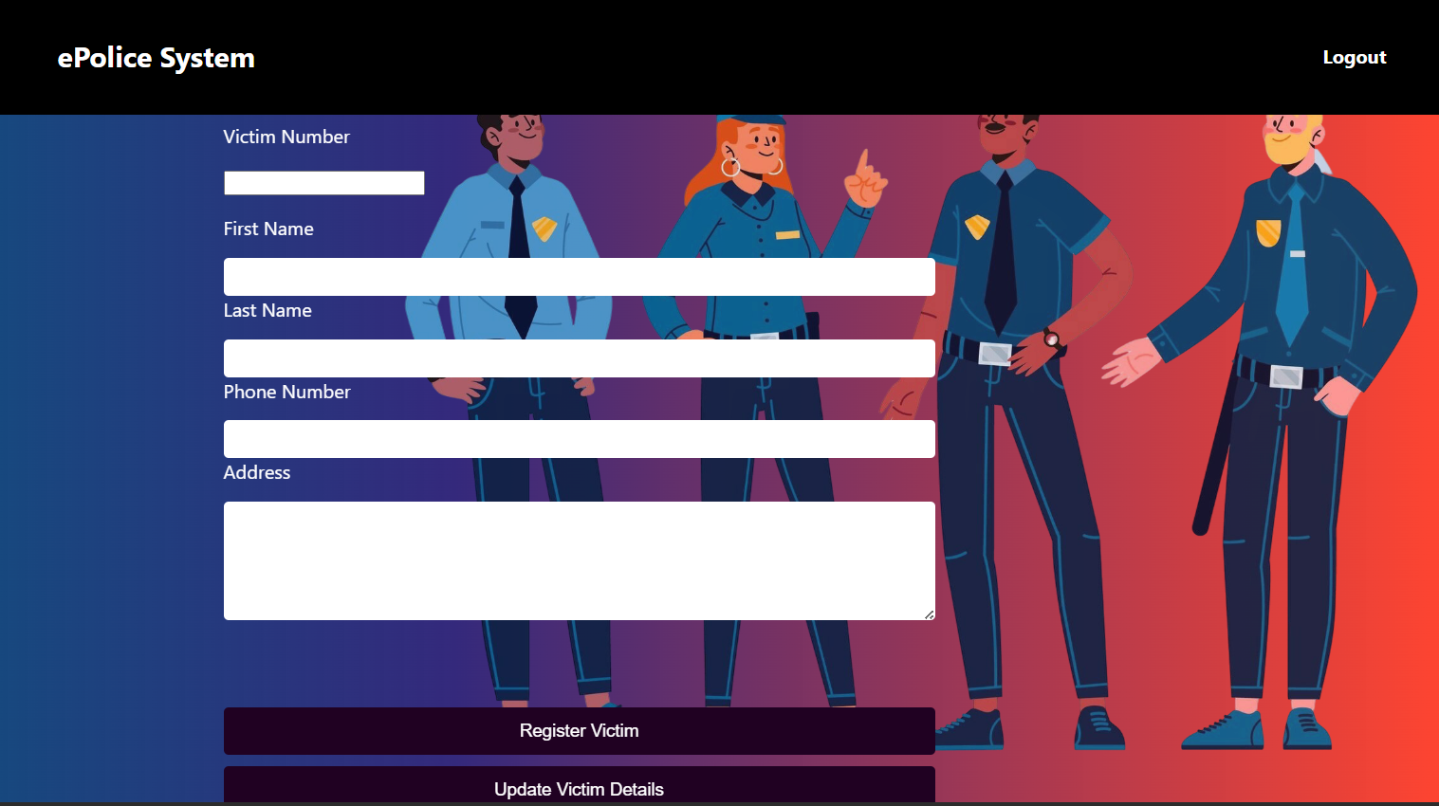

Enter victim details to either register victim or update victim details. You can click on register victim to register the victim, or click on update victim details to update victim details that already exist on the system.

**Register/update suspect**

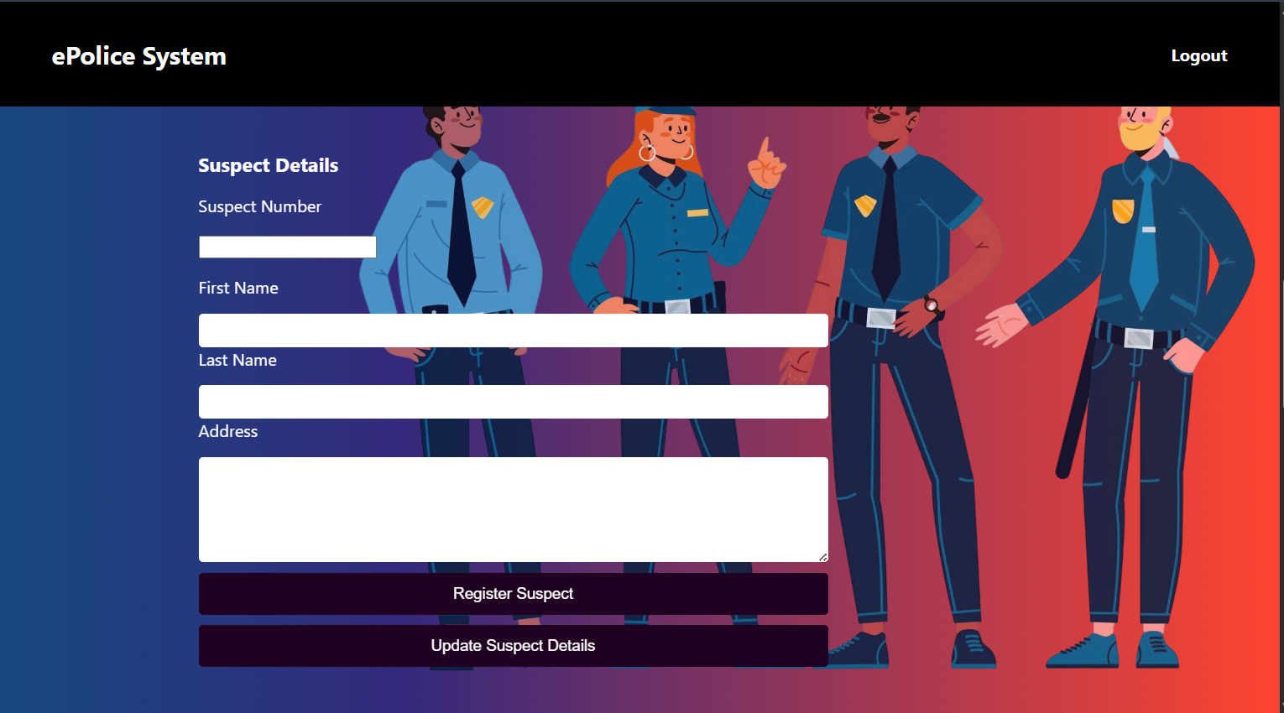

Enter suspect details. Click on register suspect button to register suspect details or click on update suspect details button to update suspect details that exist on the system.

**Register/Update evidence**

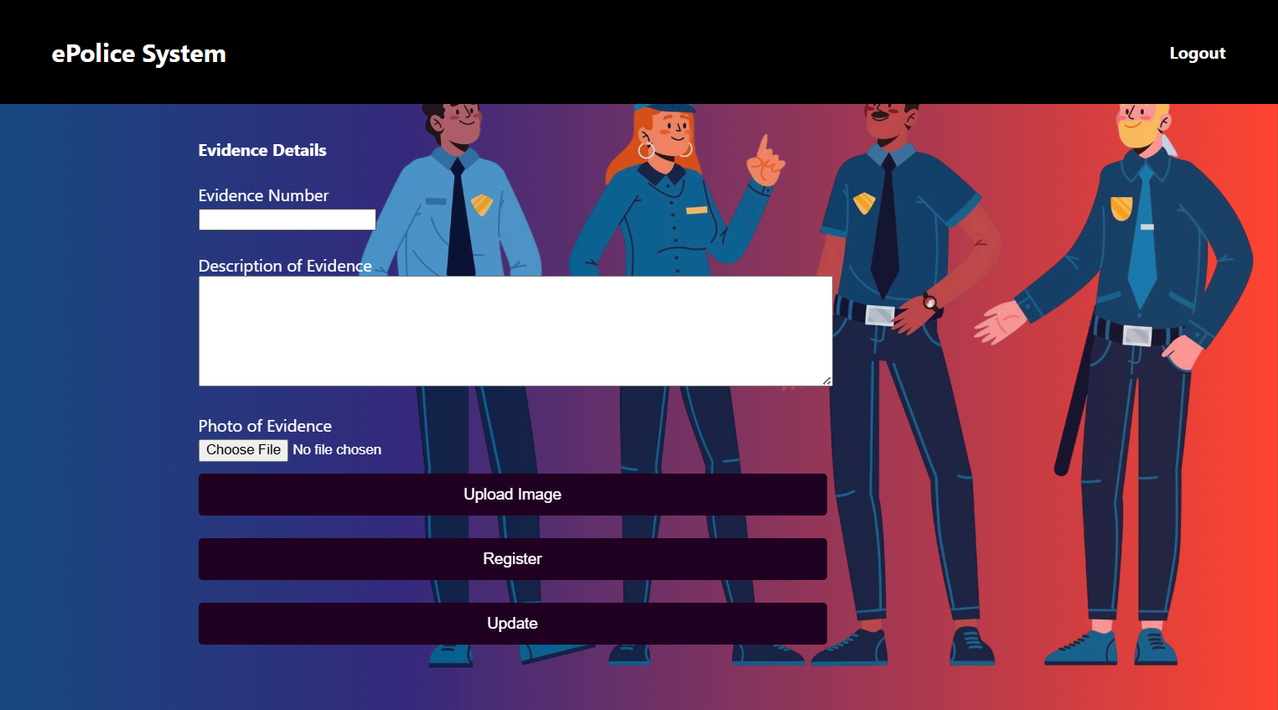

Enter evidence details. Choose photo of details and click on upload image button to successfully upload the image. Click on register button to register the evidence. Click on update button to update evidence details that already exist on the system.

**Register/Update case document details**

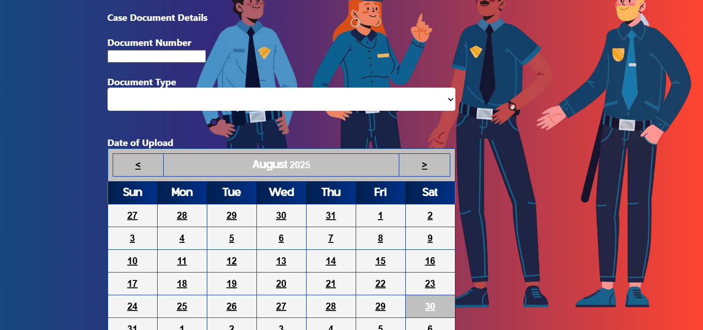

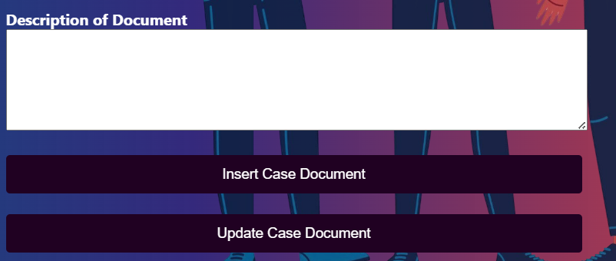

Register or update case document details. Click on insert case document button to insert case documents. Click on update case document button to update case documents.

**Delete operations**

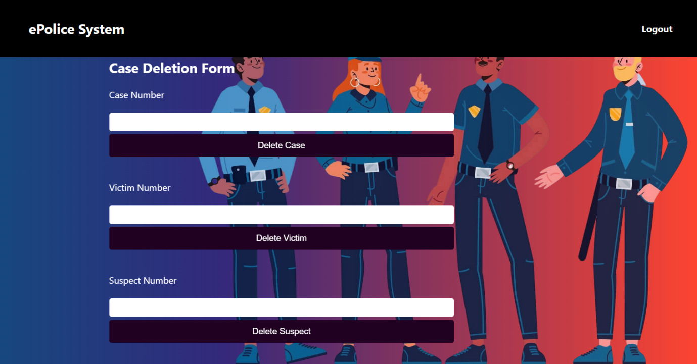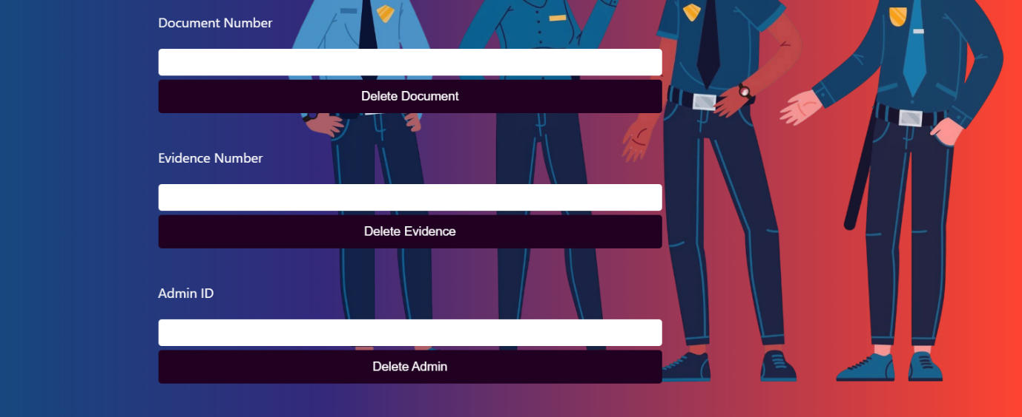

Enter the required details to delete case.

**View Databases**

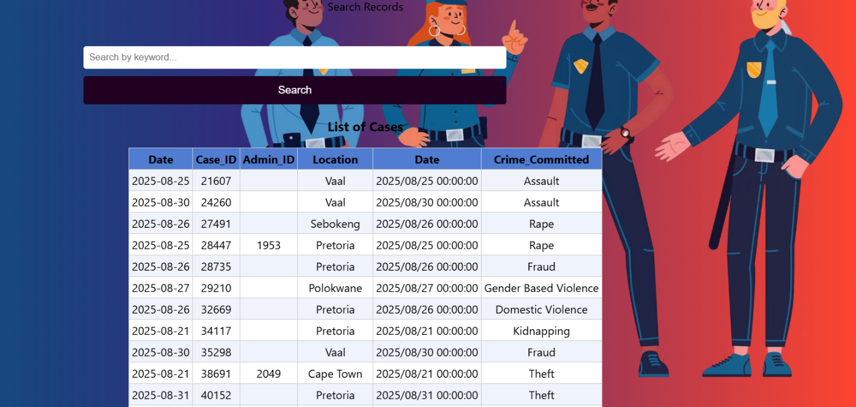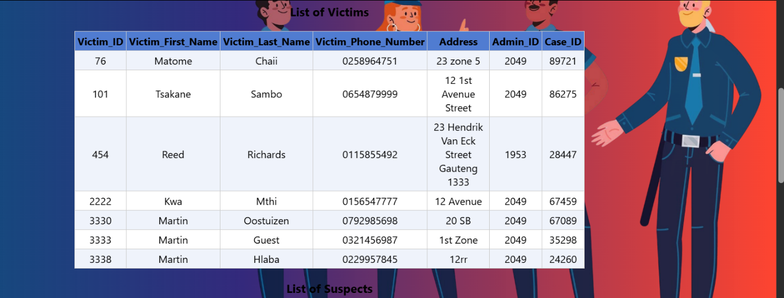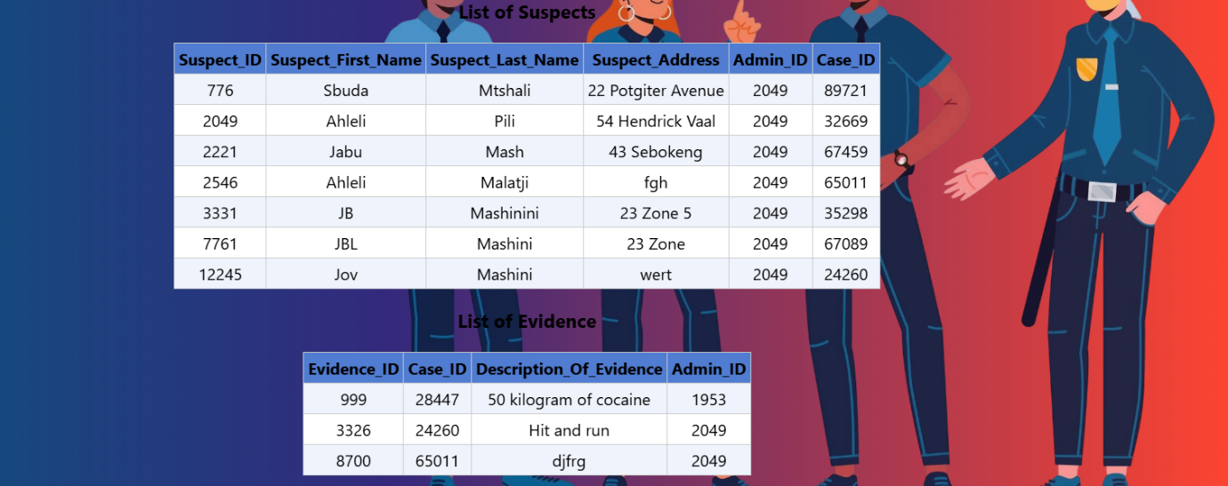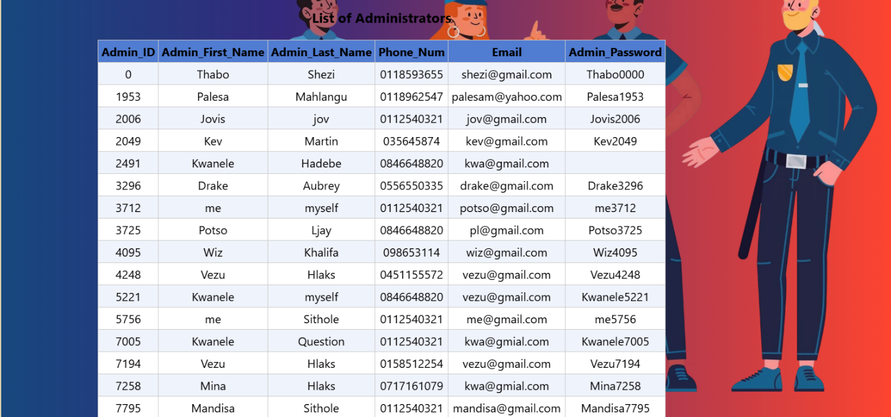

**Search by crime**

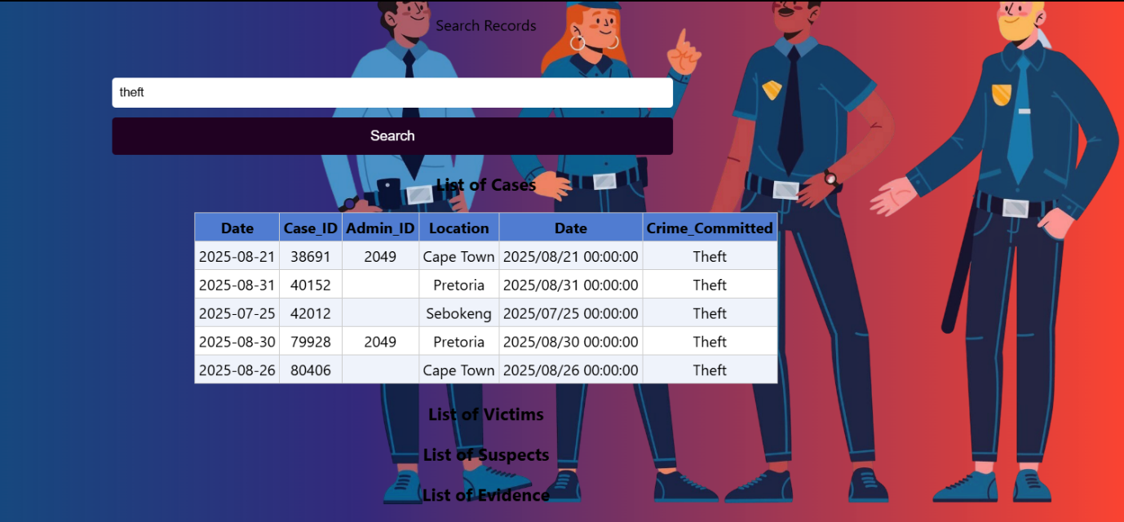

Enter type of crime committed to search details of cases related to that specific crime.

**Search by Case ID**

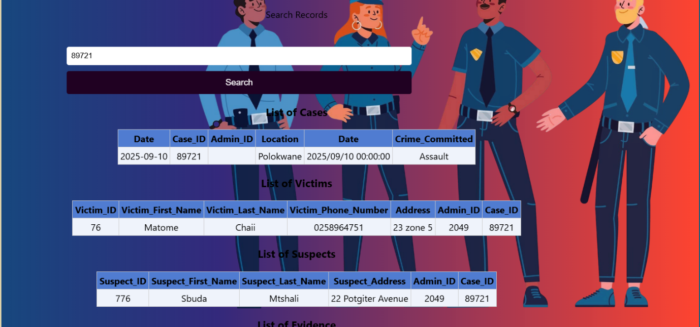

Search case by entering the case ID.

**Search by Admin ID**

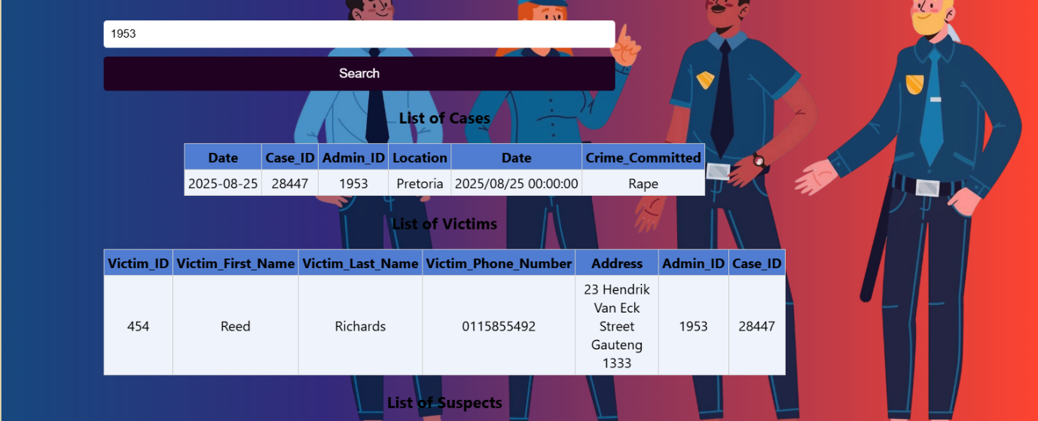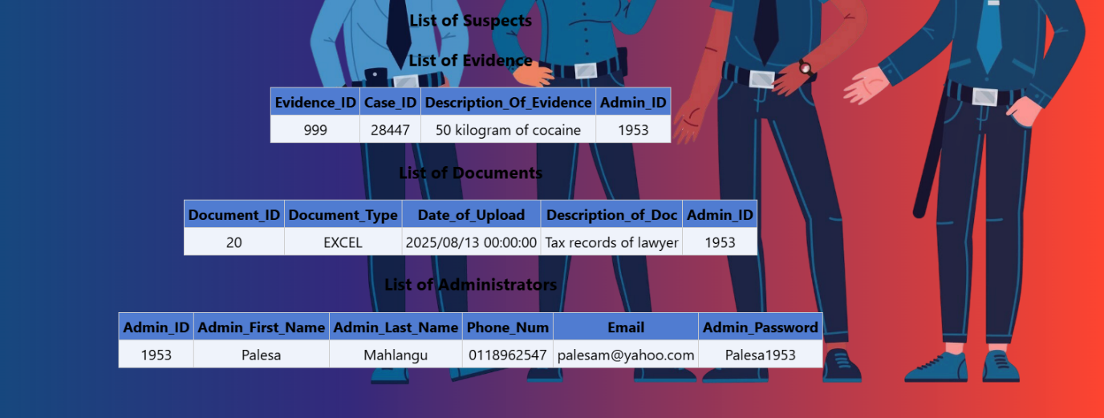

Enter Admin ID to search case

**DETECTIVE**

**Logging in**



**A police office can login by selecting their role. They can only view database, search by crime and search by case ID.**